

[Artificial Intelligence in the Life Sciences 4 (2023) 100](https://doi.org/10.1016/j.ailsci.2023.100084)084

|  |  |  |
| --- | --- | --- |
|  | Contents lists available at [ScienceDirect](http://www.ScienceDirect.com/) |  |
| ArtificialIntelligenceintheLifeSciences |
| journalhomepage:[www.elsevier.com/locate/ailsci](http://www.elsevier.com/locate/ailsci) |

ResearchArticle   
AnalysisofSwin-UNetvisiontransformerforInferiorVenaCavafilter segmentationfromCTscans✩  
Rahul Gomesa*,*∗,Tyler Phamb,Nichol Hea,Connor Kamrowskia,Joseph Wildenbergc*,*∗∗a *DepartmentofComputerScience,UniversityofWisconsin-EauClaire,EauClaire,54701,WI,UnitedStates*   
b *DepartmentofComputerScience,UniversityofMinnesota-TwinCities,Minneapolis,55455,MN,UnitedStates*   
c *InterventionalRadiology,MayoClinicHealthSystem,EauClaire,54703,WI,UnitedStates*

|  |  |  |
| --- | --- | --- |
| ARTICLE | INFO | ABSTRACT |
| Datasetlink:[https://](https://github.com/rahulgomes19/IVC_3D)  github.com/r[ahulgo](https://github.com/rahulgomes19/IVC_3D)mes19/IVC_3D | | *Purpose:*ThepurposeofthisstudyistodevelopanaccuratedeeplearningmodelcapableofInferiorVenaCava (IVC)filtersegmentationfromCTscans.ThestudydoesacomparativeassessmentoftheimpactofResidual |
| *Keywords:*  Deeplearning  Medicalimaging  Convolutionalneuralnetworks SWINtransformer  UNet  ResNet  IVCfilter | | Networks(ResNets)complementedwithreducedconvolutionallayerdepthandalsoanalyzestheimpactof usingvisiontransformerarchitectureswithoutperformancedegradation.  *MaterialsandMethods:*Thisexperimentalretrospectivestudyon84CTscansconsistingof54618slicesinvolves design,implementation,andevaluationofsegmentationalgorithmwhichcanbeusedtogenerateaclinicalreport forthepresenceofIVCfiltersonabdominalCTscansperformedforanyreason.Severalvariantsofpatch-based 3D-ConvolutionalNeuralNetwork(CNN)andtheSwinUNetTransformer(Swin-UNETR)areused toretrieve thesignatureofIVCfilters.TheDiceScoreisusedasametrictocomparetheperformanceofthesegmentation models.  *Results:*ModeltrainedonUNetvariantusingfourResNetlayersshowedahighersegmentationperformance achievingmedianDice=0.92[Interquartilerange(IQR):0.85,0.93]comparedtotheplainUNetmodelwith fourlayershavingmedianDice=0.89[IQR:0.83,0.92].SegmentationresultsfromResNetwithtwolayers achievedamedianDice=0.93[IQR:0.87,0.94]whichwashigherthantheplainUNetmodelwithtwolayers atmedianDice=0.87[IQR:0.77,0.90].ModelstrainedusingSWIN-basedtransformersperformedsignificantly betterinbothtrainingandvalidationdatasetscomparedtothefourCNNvariants.ThevalidationmedianDice washighestin4layerSwinUNETRat0.88followedby2layerSwinUNETRat0.85.  *Conclusion:*UtilizationofvisionbasedtransformerSwin-UNETRresultsinsegmentationoutputwithbothlow biasandvariancetherebysolvingareal-worldproblemwithinhealthcareforadvancedArtificialIntelligence (AI)imageprocessingandrecognition.TheSwinUNETRwi[llreduc](https://github.com/rahulgomes19/IVC_3D)ethetimespentmanuallytrackingIVCfilters bycentralizingwithintheelectronichealthrecord.Linkto[GitHub](https://github.com/rahulgomes19/IVC_3D) repository. |

**1.Introduction**

InferiorVenaCava(IVC)filtersaremedicaldevicesplacedinside theIVCtoreducethemorbidityandmortalityofVenousThromboem-bolism(VTE),specificallyPulmonaryEmbolism(PE).IntheUnited States,thereareabout60,000to100,000deathsperyearduetoVTE [3].IVCfiltrationisanalternativeoptionformanagingtheseconditions whenanticoagulation,thefirstlinetreatmentforVTE,cannotbeused–

usuallyduetoahighriskofmajorbleeding[15].TheNationalHospital DischargeSurveyrecordedatotalof803,00IVCfiltersplacedbetween 1985to2006,andabout259,000filterswereestimatedtohavebeen placedin2012[3].

Currently,thetwotypesofIVCfiltersinusewithintheUnited Statesarepermanentfiltersandretrievablefilters.Retrievablefilters originatedinthe1990sandweredesignedwiththeoptionofbeing retrievedorleftinplaceaftertheriskofPEsubsided[18].Whenre-

✩ ThisdocumentistheresultsoftheresearchprojectfundedbytheMayoClinic-UWEauClaireResearchInnovationCouncil,andNationalScienceFoundation-ResearchExperienceforUndergraduatesOAC-2150191.ThecomputationalresourcesofthestudywereprovidedbytheBlugoldCenterforHigh-Performance ComputingunderNationalScienceFoundationgrantCNS-1920220.

* Correspondingauthor.

** Principalcorresp[ondingauthor.](mailto:gomesr@uwec.edu)

*E-mailaddresses:* [gomesr@uwec.edu](mailto:gomesr@uwec.edu) (R. Gomes),[Wildenberg.Joseph@mayo.edu](mailto:Wildenberg.Joseph@mayo.edu) (J. Wildenberg).

<https://doi.org/10.1016/j.ailsci.2023.100084>  
[Received8June2023;Receivedinrevisedfo](https://doi.org/10.1016/j.ailsci.2023.100084)rm25July2023;Accepted9August2023

Available online 18 August 2023

2667-3185/© 2023 The Author(s). Published by Elsevier B.V. This is an open access article under the CC BY licens[e (http://creativecommons.org/licenses/by/4.](http://creativecommons.org/licenses/by/4.0/)0/).

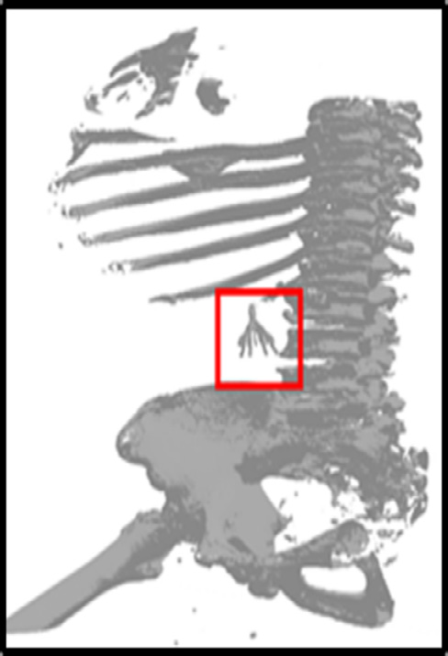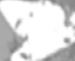

*R. Gomes, T. Pham, N. He et al.*

|  |  |  |
| --- | --- | --- |
|  |  |  |
|  |

**Fig. 1.** (a)AnexampleofIVCfilterusedinpatients.(b)showsa3Drendering ofCTscanwiththepositionofIVCfilterinthepatient.

trievedattheappropriatetime,retrievableIVCfiltersprovideanadded benefitofreducingtheoccurrenceoflong-termcomplicationsassoci-atedwiththeirpermanentcounterpart[5,26].WhileretrievableIVC filterswereadvertisedwiththeoptionofhavingitremaininapa-tient’sbody,seriouslong-termcomplicationscanoccur.LeavingIVC filtersinthebodyformorethan30daysincreasestheriskofDeep VeinThrombosis(DVT),filtermigration/embolization,filterfracture, andIVCperforation[10,4,2].Toaddressthesepotentialcomplications, theFDAin2010recommendedthatphysiciansconsidertheremoval ofretrievableIVCfiltersassoonastheriskforPEsubsided.Then,in 2014,theFDAissuedguidancethat,oncethepatientisnolongeratrisk forPE,therisksofkeepingfiltersinthepatientbegintooutweighthe benefitsbetween29to54daysafterimplantation[8].

AlthoughremovaloftheseIVCfilterisassimpleassettingupanap-pointmentwiththeclinicianwithin30daysoftheprocedure,moststud-iesreportedanaverageretrievalratebetween20%and30%[28,23]. TherearethreefactorsrelatingtotheunderwhelmingrateofIVCfilter retrieval:(a)patient,(b)system,and(c)technicalfactors.Patientfac-torsincludesocioeconomicstatusandmedicalcomorbidities.Patients couldhavelimitedresources,suchashealthcarecoverageandtrans-portation,whichresultsinpoorclinicalfollow-up.Patientswithmany comorbiditiesmayhaveahigherperiproceduralriskthantherisksof leavingthefilterinplace.Thesystemfactorsconsistofpoortracking andpatientfollow-up[8] mostlyarisingduetopatientsmovingtoadif-ferenthealthcaresystemduetojob,education,andotherfactorsand nottransferringrecordsfromtheirpast.Thetechnicalfactorsinclude thechallengesencounteredduringretrievals,suchasfiltertiltorfrag-mentation.AneasywaytotracktheseIVCfiltersatamuchlaterdate istohavealightweightfilterdetectionalgorithmthatrunswhenever apersongetsaCTscanforotherhealthreasonstherebyuncovering patientswhowouldotherwisebelosttofollow-up.Fig. 1 showsanex-ampleofIVCfilterusedduringtheprocedure.Withthesethreeissues leadingtounderwhelmingretrievalrates,itiscrucialthattheprocessof IVCtracking,andretrievalbeintegratedinthegeneralCTscanpipeline toenablerapiddiagnosis.Theproposedresearchexploresthedevelop-mentofthesegmentationalgorithmwhichwillbeanintegralpartof thispipeline.Thereisalsoaneedtoensurethatthisalgorithmisvery accuratewithsignificantlylessfalsepositivestherebysavingvaluable timeforclinicians.

ResearchhasalreadybeenconductedonclassifyingthetypeofIVC filterfoundinradiographsusingCNNsinthecontextofmedicalimage analysis.Inonestudy,radiographicpicturesthathadbeenmanually croppedwereutilizedtoclassify14differentIVCfilters.Thiscatego-rizationwascarriedoutusinga50-layerResNetarchitecturewitha

2

*R. Gomes, T. Pham, N. He et al.*

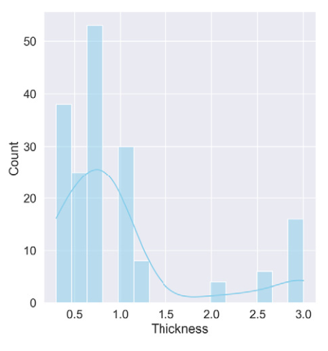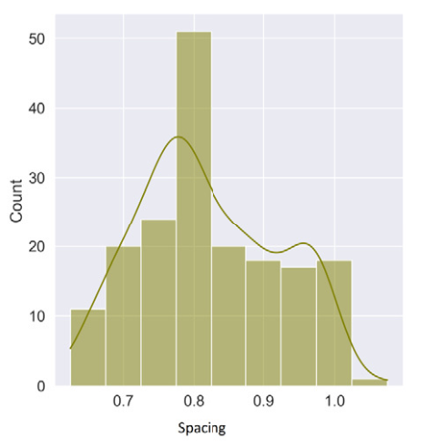

 

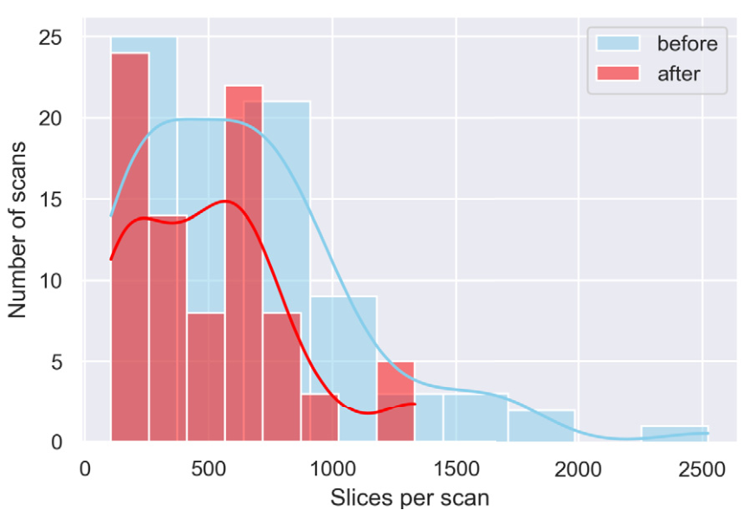



**Fig. 2.** Metricsof84CTscansusedformodeltraining.(a)Showstheslice thicknessinmm,(b)Showstheslicepixelspacinginmm,and(c)showsthe numberofslicesperscanbefore(blue)andafter(red)applicationof40cm spatialcropping.Itisobservedthatthenumberofslicesreducessignificantly therebyremovingredundantdata.

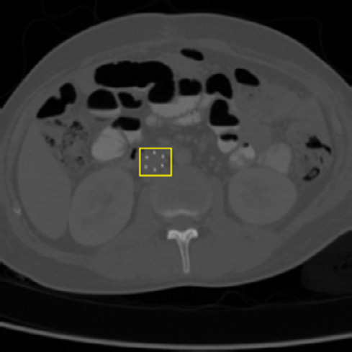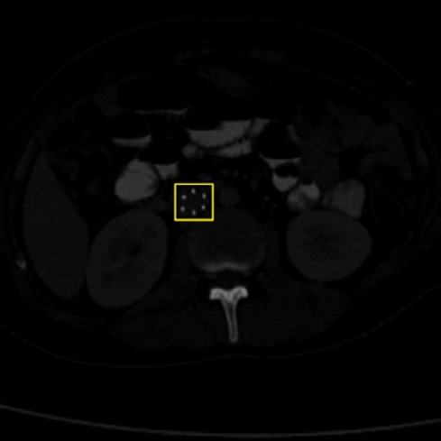

 

**Fig. 3.** Slices (a) before and (b) after HU normalization.

betterperformance.The20%spatialcroppingwasdoneequallytoeach ofthefouredges.Asaresult,theoriginal(512×512)CTscanslices weredownsizedto(307×307)beforeresamplingto(256×256). Followingthespatialcropping,slicesofeachCTscan40cmbelowthe cranial-mostslicewerediscarded.A40cmcut-offwaschosenbecause almostallIVCfiltersareplacedwithintheuppertomidabdomen.The cut-offwasabletodecreaseCTslicesby19.01%asshowninFig. 2c followedbyresamplingtohave128slicesperscan.Theminimumand maximumHUforthestudywassetat1HUand2500HUrespectively. Thesescanswerethennormalizedbetween0and1beforedeeplearn-ingwasapplied.ThishardnormalizationschemeworkswellforIVC filterdetectionasshownin[14].Thesegmentationmaskswerecreated underthesupervisionofaboard-certifiedradiologist.Fig. 3 showsa slicebeforeandafterapplicationofhardnormalizationscheme.

3

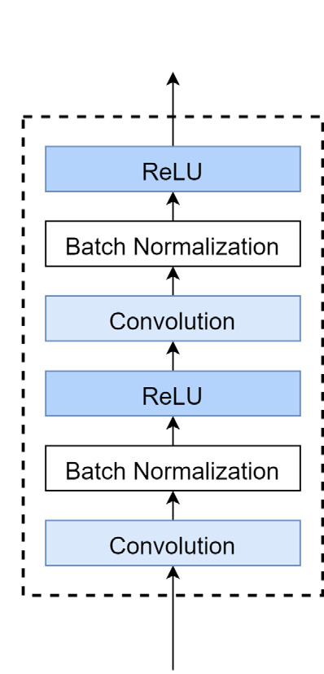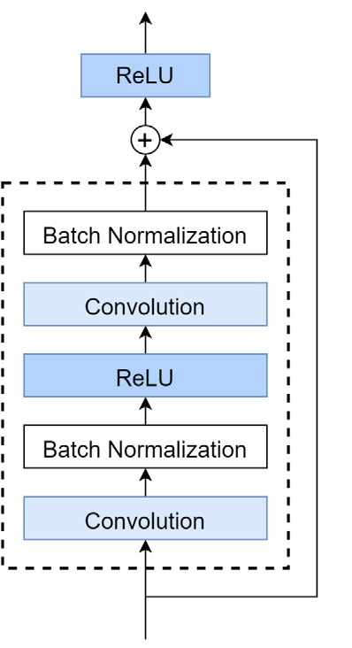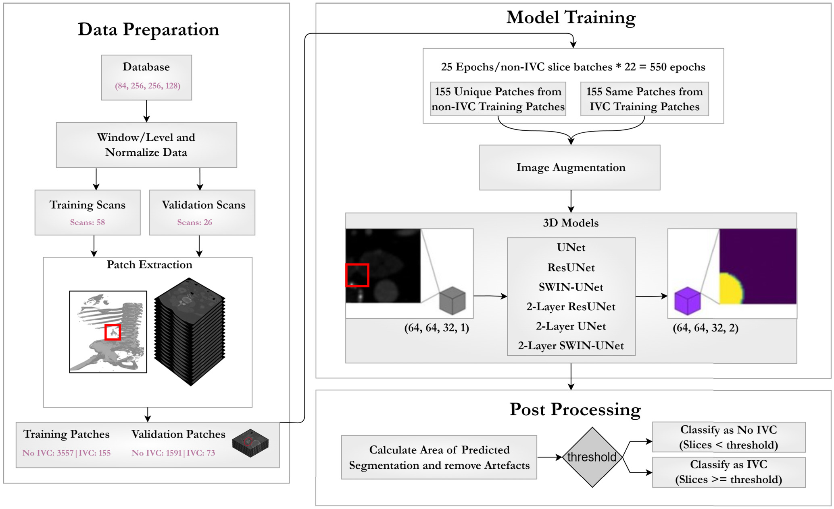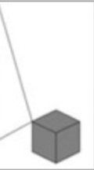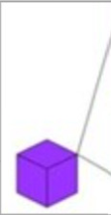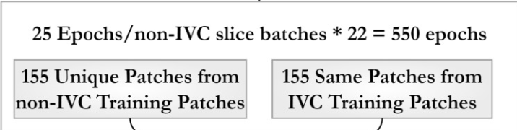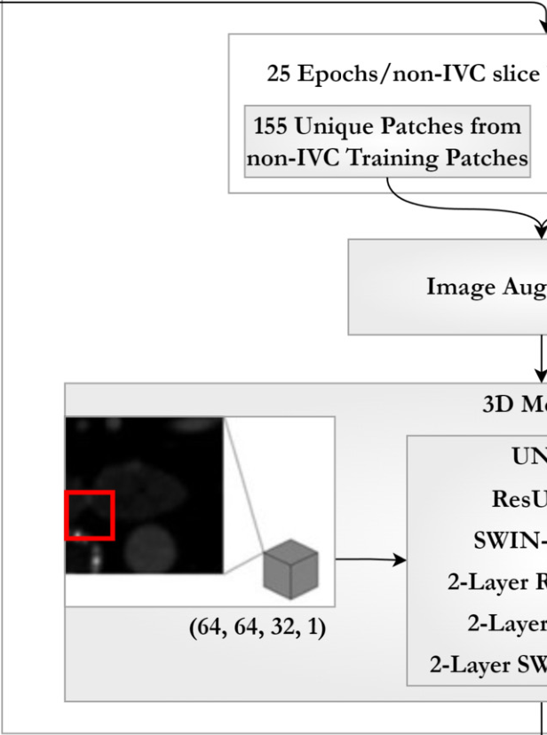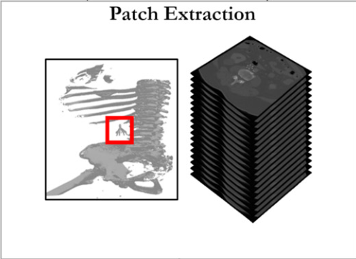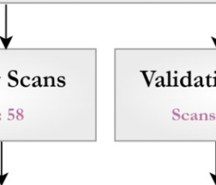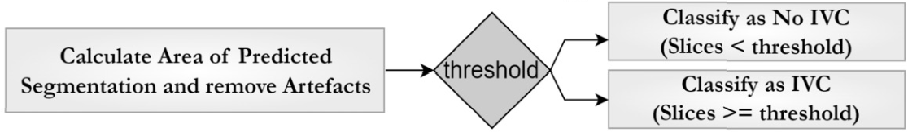

*R. Gomes, T. Pham, N. He et al.*  *Artificial Intelligence in the Life Sciences 4 (2023) 100084*

**Fig. 4.** OverviewoftheentiretrainingandvalidationprocessoftheIVCpredictionpipeline.Afterdatanormalization,slicesaresplitintotrainingandvalidation.

Thisisfollowedby3D-patchextraction.Patchesarefedto3D-UNetvariantsforIVCfiltersegmentation.Finally,imageprocessingalgorithmsremoveartefactsto

classifyascanhavingIVCfilter.

 

**Fig. 5.** Overviewofa)ResNetblocksandb)UNetblocksusedinthetraining process.

wastrainedonthedatasetprovidedaspartofthe2021Multi-modal BrainTumorSegmentationChallenge(BraTS).Comparedtothewin-ningmethodologiesofthe2021BraTS,SwinUNETRoutperformedall othermodelswithatleast0.7%,0.6%,and0.5%greaterDicescores onEnhancingTumor(ET),WholeTumor(WT),andTumorCore(TC) semanticclassesrespectively.Themodelalsoachievedahighlycom-petitiveperformanceinthetestingphase.SwinUNETRhasalsobeen appliedtoheadandneckprimarytumorsandlymphnodesegmenta-tionusingFGD-PET/CTimages.524samplesprovidedbytheHeadand NeckTumor(HECKTOR)2022challenge.SwinUNETRwaspre-trained

4

*R. Gomes, T. Pham, N. He et al.*  *Artificial Intelligence in the Life Sciences 4 (2023) 100084*

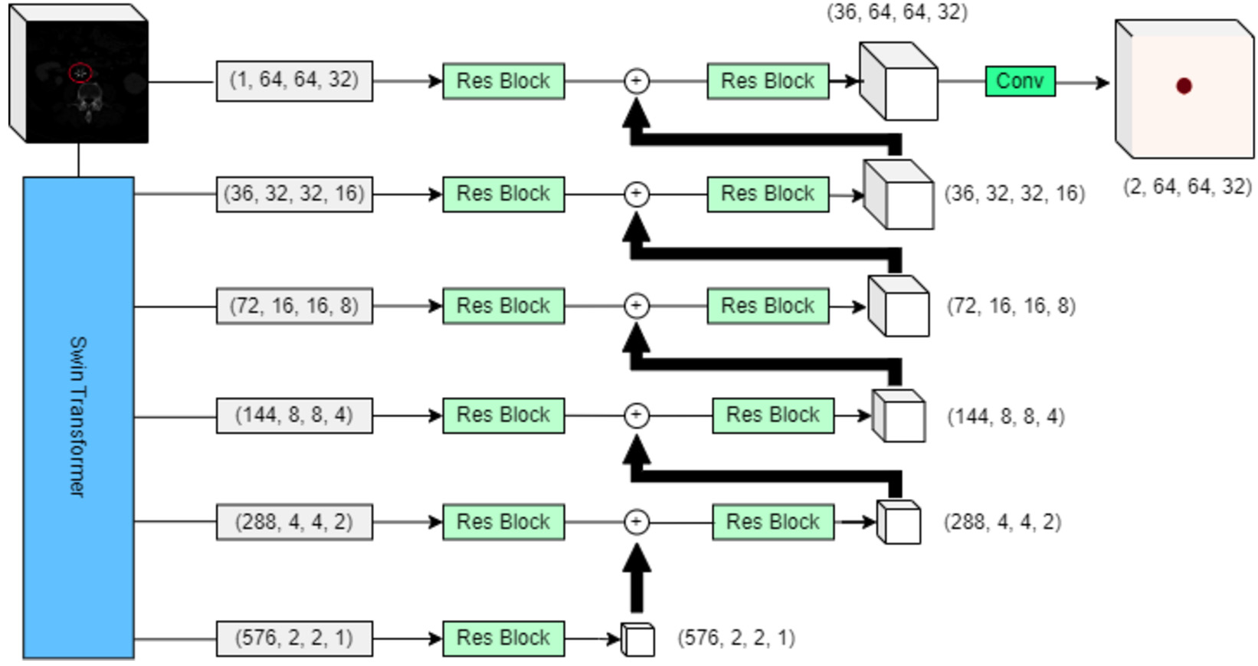

**Fig. 6.** Overview of SWIN-UNet used in the training process.

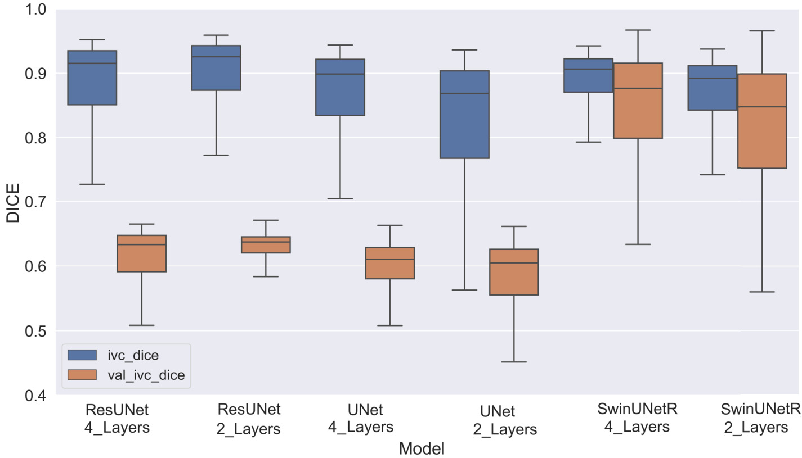

**Fig. 7.** Box plot showing the Dice Score distributions of the six model variants used in this study.

**Table 1**   
Dicescoresfordifferentmodelvariantsderivedfromtrainingandvalidationdatasets.

|  |  |  |  |  |  |  |  |
| --- | --- | --- | --- | --- | --- | --- | --- |
|  |  | UNet Simple |  | ResNet blocks |  | Swin UNETR |  |
|  |  | 2 Layer | 4 Layer | 2 Layer | 4 Layer | 2 Layer | 4 Layer |
| Train | Median  IQR | 0.87  0.77-0.90 | 0.89  0.83-0.92 | 0.93  0.87-0.94 | 0.92  0.85-0.93 | 0.89  0.84-0.91 | 0.90  0.87-0.92 |
| Valid | Median  IQR | 0.6  0.55-0.63 | 0.61  0.58-0.63 | 0.64  0.62-0.65 | 0.63  0.59-0.65 | 0.85  0.75-0.89 | 0.88  0.79-0.92 |

ThetwovariantsoftheSwinUNETRarchitecturewasimplemented toallowforcomparisonwiththefourUNetvariants.Oneutilizesthe fourstagedesigndetailedbyHatamizadehet al. [16].Themodelwas implementedusingtheMONAIlibrary,whichlimitsthestartingnum-beroffilterstoamultipleof12.Therefore,bothvariantsareimple-mentedwithastartingfeaturesizeof36tobestmatchtheotherUNet variantimplementations.Eachsubsequentstagedoublesthenumberof features,toamaxof576featuresinthe4-stagevariantand144fea-turesinthe2-stagevariant.TheoutputoftheSwinUNETRateachstage isfedintoaresidualblockandthenconcatenatedwiththedeconvolu-tionofthepreviousstageinastandardUNetdecoder.Theoutputofthe

5

*R. Gomes, T. Pham, N. He et al.*

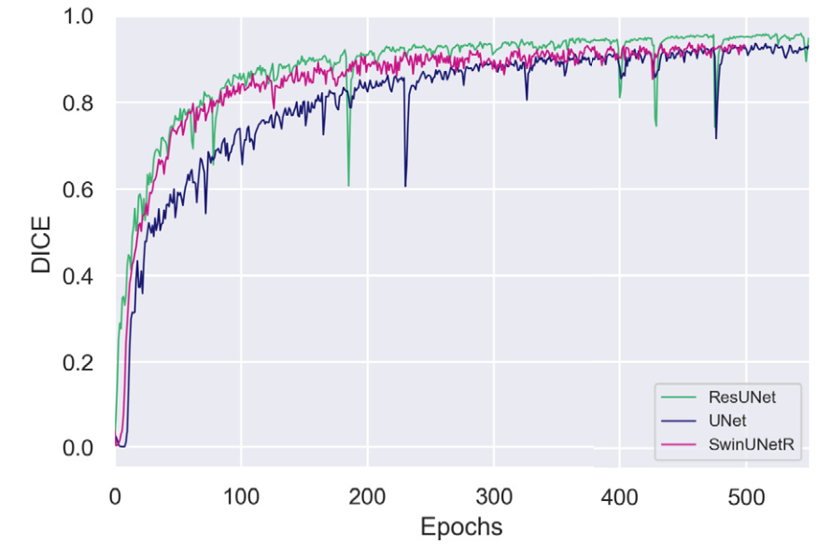

*Artificial Intelligence in the Life Sciences 4 (2023) 100084*

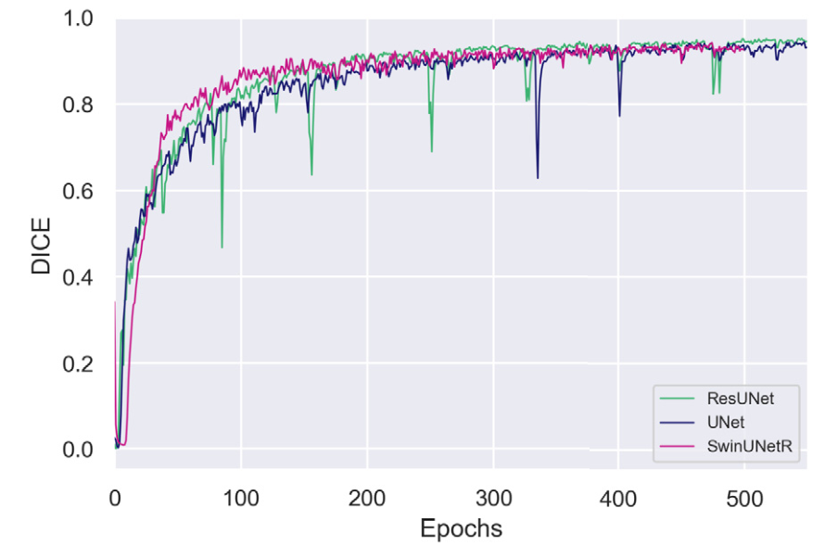

 

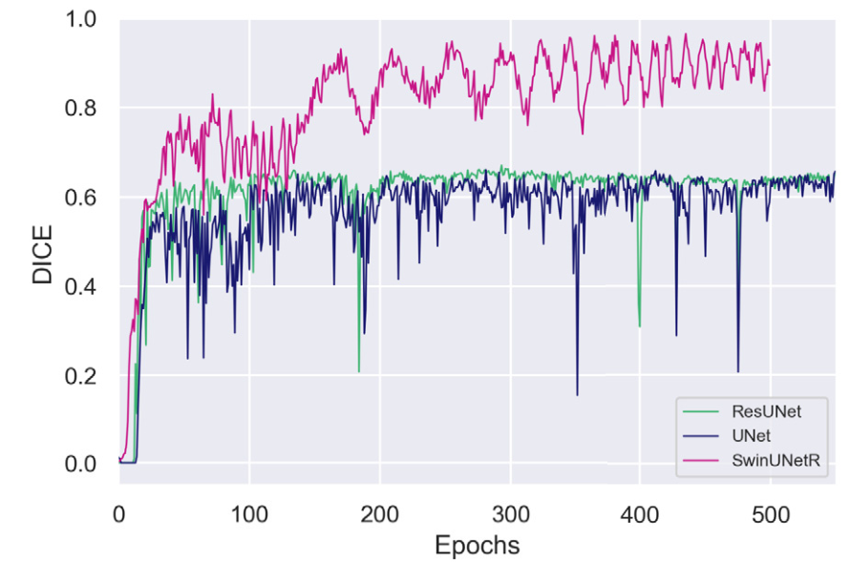

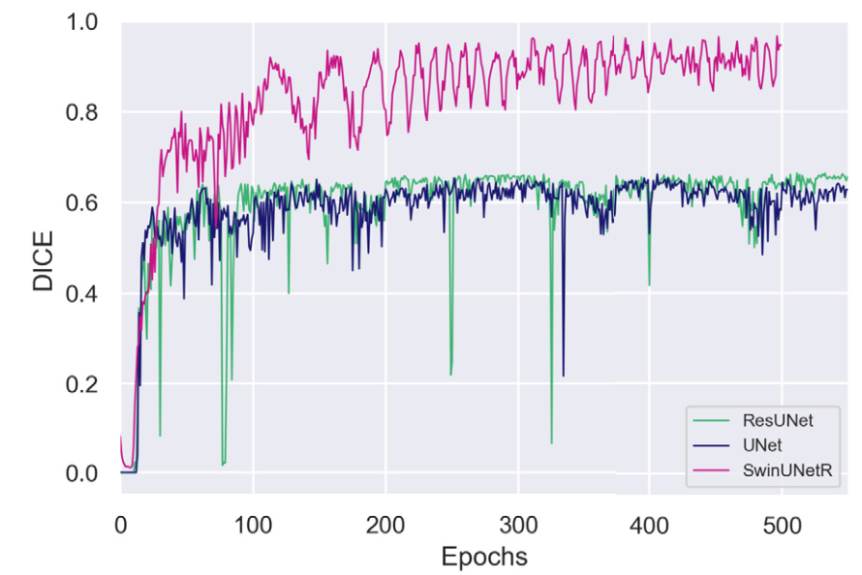

 

**Fig. 8.** Overview of IVC Dice for training data for a) Two stage and b) Four stage models and validation data for c) Two stage and d) Four stage models.

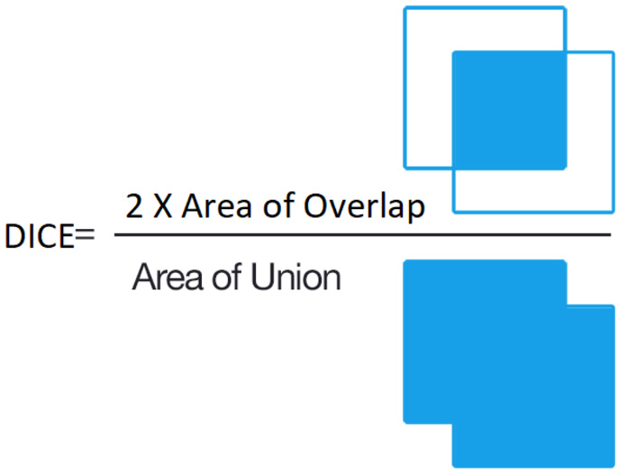

**Fig. 9.** FigureshowingcalculationofDiceScoreadoptedfromimageundera CCBY-SA4.0license.

metricwhichisacommontoolincomputervisiontasks.Inthecon-textofimagesegmentation,Diceisusedtoassesstheaccuracyofa segmentationmodel’spredictionscomparedtothegroundtruthseg-mentationmasksasshowninFig. 9.TheDicescorerangesfrom0to 1with1beingacompletematchbetweensegmentationandground truth.ConsideringthehighlyimbalancednatureofIVCpixels,theDice providedasimpleandintuitivewaytoinvestigatethesegmentation performanceacrossdifferentmodelswhichwouldotherwisehavebeen challengingifsensitivityandspecificitywereusedduetosuchalarge amountofbackgroundclass.Onthetrainingdataset,theResNetmodels performedsignificantlybettercomparedtoplainUNetversions.ResNet withtwolayersachievedthehighestmedianDice=0.93[IQR:0.87, 0.94]whiletheUNetmodelwithtwolayersachievedthelowestme-dianDice=0.87[IQR:0.77,0.90].Resultsfromapplyingthemodel onvalidationdataalsorevealedasimilartrendwithResNetvariants achievingahigheraccuracy.ResNetwithtwolayersagainachievedthe

6

*R. Gomes, T. Pham, N. He et al.*

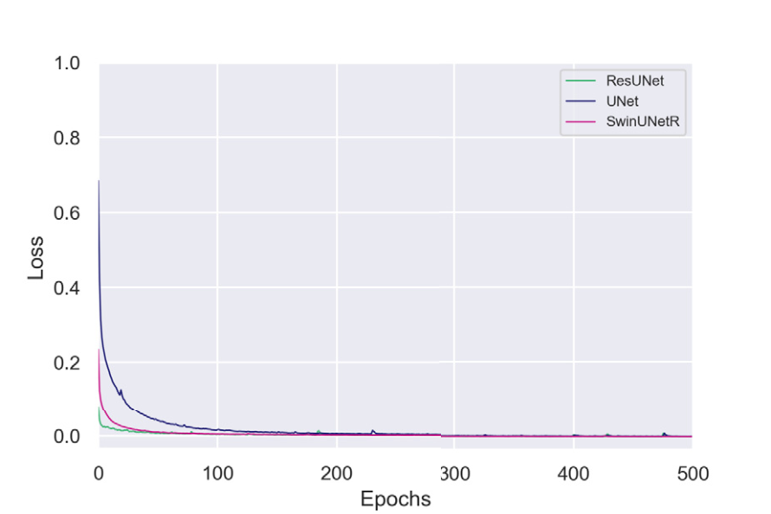

*Artificial Intelligence in the Life Sciences 4 (2023) 100084*

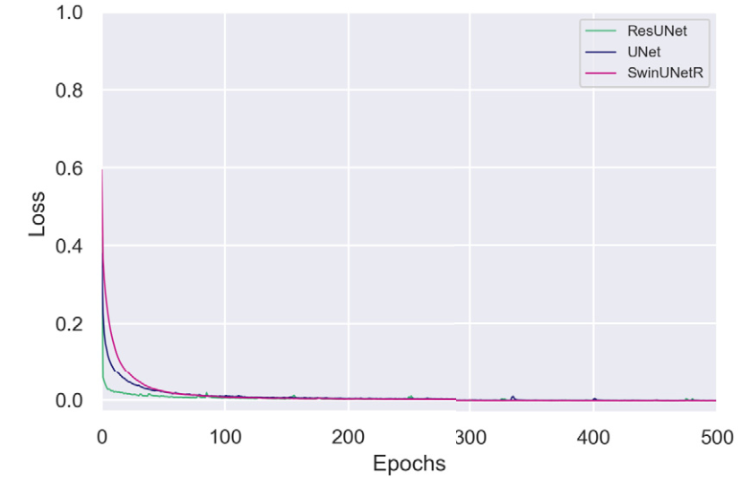

 

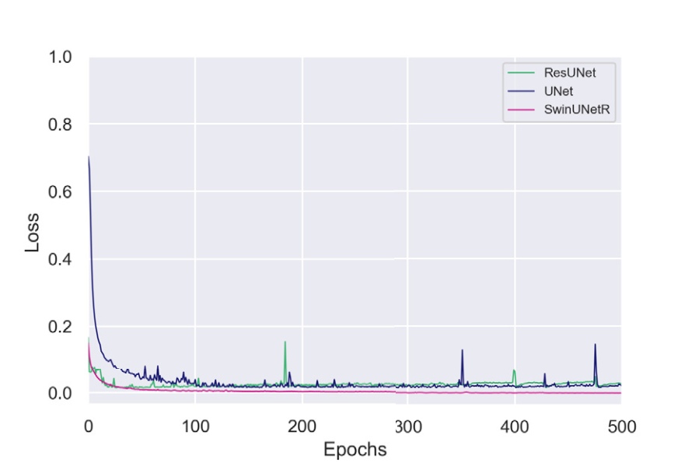

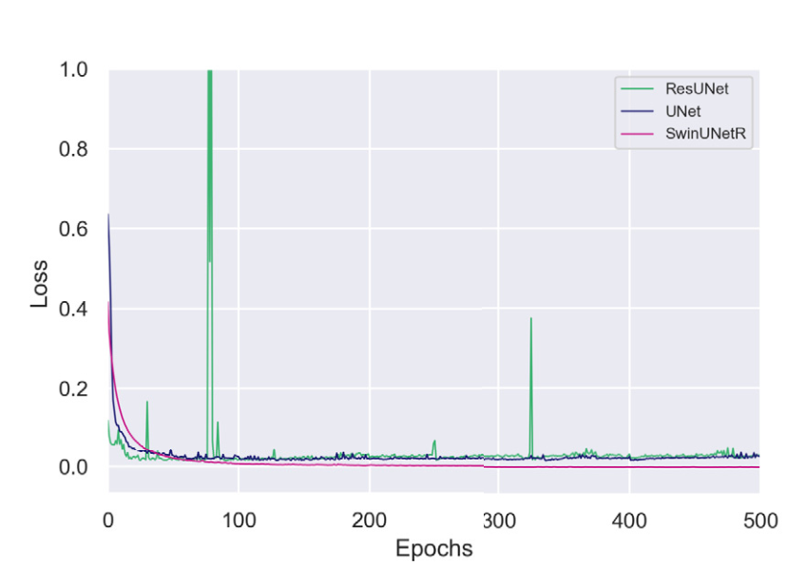

 

**Fig. 10.** Overview of IVC Loss for training data for a) Two stage and b) Four stage models and validation data for c) Two stage and d) Four stage models.

distributionoffilterandnofilterpatchescomplementedwithaugmen-tationduringtrainingprocess.Sixdifferentsegmentationapproaches werecomparedtofurtherensuresparsityoffiltersignaturewouldnot impacttheoutcome.ItwasobservedthatusingResNetblocksoutper-formedbasicconvolutionblocksinsegmentation.TheResNetblocks alsoreducedtherateoffalse-positives.Thesefalsepositiveswerecom-prisedmostlyofbonesandcalcificationaroundthespine.Aprobable causeforthisissuewasthelackofskip-connectionsinbasicUNetblocks thatispresentinResNet.Theskipconnectionsenableanetworkto learnresidualmappings,i.e.,thedifferencebetweentheinputandout-put.SincetheIVCfiltersignatureisverylowcomparedtobackground, thekernelsusedindeeplayersfinditchallengingtodetectfeatures uniquetofilters.Asskipconnectionsbringbacktheinputfromshallow layers,thenetworklearnsmoreeasilytheunderlyingfilterpatterns. Anotherverysignificantoutcomeofthisresearchindicatesthatdeep learningmodelslikeSwinUNETRwithtransformersastheirbackbone arecapableofmaintainingconsistentperformanceacrossbothtraining andvalidationdatasets.ThisisincontrasttoCNNbasedsegmenta-tionwhichshowsadropinsegmentationaccuracyforvalidationdata. Fig. 11 furthercorroboratesthisfact.NoticehowbothSwinUNETR modelsareabletoconformthesegmentationtotheactualshapeof thefilterswhereastheCNN-derivedUNetandResUNetmodelslose theedgesduringthesegmentationprocess.Also,thefourlayermod-elsachievebettersegmentationhencelesspost-processingastheirare nospurioussegmentationregionsaroundthescans.

Acomparativelayeranalysisresultedinanoptimizedmodelwith asmallerfootprint.WhileResNetblocksincreasethesegmentation performance,theyalsorequiremoreparameters.Forexample,the twolayerResNetmodelusedinthisresearchutilizedaroundthree millionparameters(3,155,810)comparedto53millionparameters (53,154,018)inthefourlayerResNetmodels.TheSwinUNETRalso providedbetterresultswithverycomparableusageoftrainableparam-

7

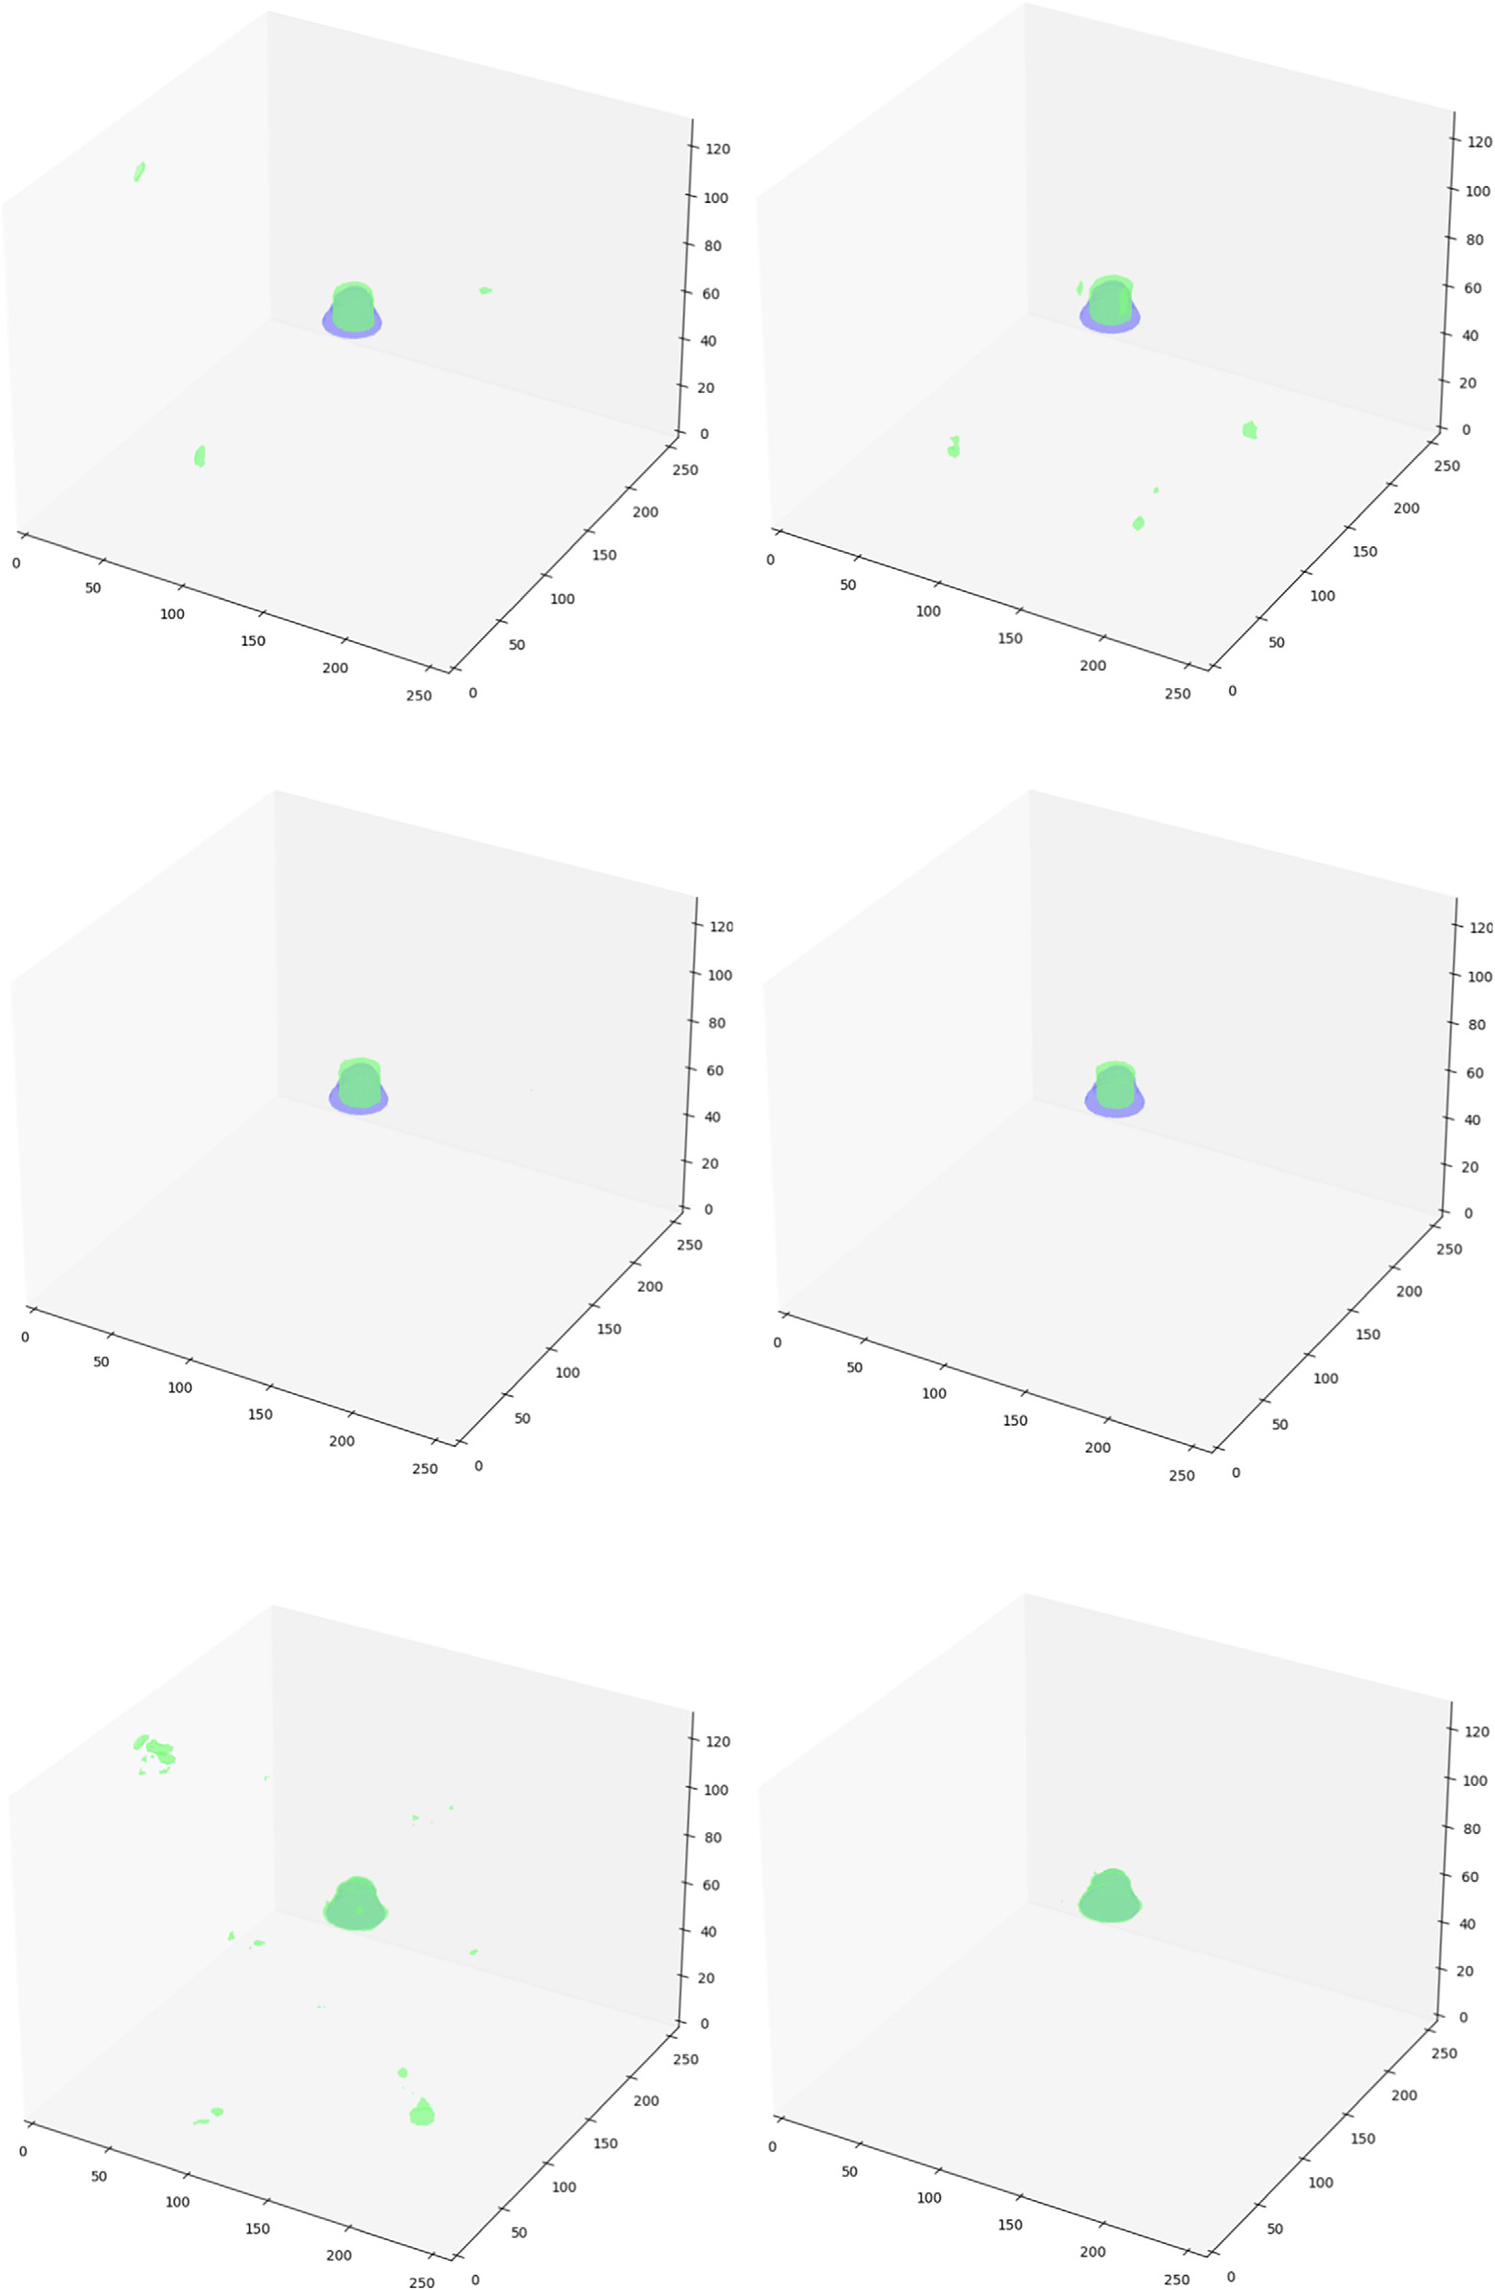

*R. Gomes, T. Pham, N. He et al.*

 

**Fig. 11.** Overviewofresultsa)UNet2Layerb)UNet4layer,c)ResUNet2Layer,d)ResUNet4layer,e)SwinUNETR2Layer,andf)SwinUNETR4Layer.Results indicateSwinUNETR4LayerisabletoconformtotheshapeofIVCFilterswithoutanyfalsepositives.

8

*R. Gomes, T. Pham, N. He et al.*

**CRediTauthorshipcontributionstatement**

**RahulGomes:** Conceptualization,Software,Methodology,Supervi-sion,Fundingacquisition,Writing–originaldraft,Writing–review& editing.

**TylerPham:** Datacuration,Software,Investigation,AImethodol-ogy,Writing–originaldraft.

**NicholHe:** Datacuration,AImethodology,Visualization,Writing–originaldraft.

**ConnorKamrowski:** Datacuration,Algorithmvalidation,Software, Visualization.

**JosephWildenberg:** Conceptualization,Software,Validation,Fund-ingacquisition,Projectadministration,Writing–review&editing.

**Declarationofcompetinginterest**

Theauthorsdeclarethattheyhavenoknowncompetingfinancial interestsorpersonalrelationshipsthatcouldhaveappearedtoinfluence theworkreportedinthispaper.

**Dataavailability**

<https://github.com/rahulgomes19/IVC_3D>.

**References**

[1] [Ahsan M,Gomes R,Denton A.Applicationofaconvolutionalneuralnetworkusing transferlearningfortuberculosisdetection.In:2019IEEEinternationalconference onelectroinformationtechnology(EIT).IEEE;2019.p. 427–33.](http://refhub.elsevier.com/S2667-3185(23)00028-4/bibD7D029BD758AD45C9F495A80E83E7710s1)

[2] [Angel LF,Tapson V,Galgon RE,Restrepo MI,Kaufman J.Syste](http://refhub.elsevier.com/S2667-3185(23)00028-4/bibD7D029BD758AD45C9F495A80E83E7710s1)[maticreviewofthe](http://refhub.elsevier.com/S2667-3185(23)00028-4/bib015FB457F6D6A0CD493ACCEE3C332D1Bs1)  [useofretrievableinferiorvenacavafilters](http://refhub.elsevier.com/S2667-3185(23)00028-4/bib015FB457F6D6A0CD493ACCEE3C332D1Bs1).[JVascIntervRadiol2011;22:1522–30.](http://refhub.elsevier.com/S2667-3185(23)00028-4/bib015FB457F6D6A0CD493ACCEE3C332D1Bs1) [3] [Ayad MT,Gillespie DL.Long-termcomplicationsofinferiorvenacavafilters](http://refhub.elsevier.com/S2667-3185(23)00028-4/bib015FB457F6D6A0CD493ACCEE3C332D1Bs1).[JVas](http://refhub.elsevier.com/S2667-3185(23)00028-4/bib015FB457F6D6A0CD493ACCEE3C332D1Bs1)[c](http://refhub.elsevier.com/S2667-3185(23)00028-4/bib056AED253BF5AB475C37A80ECF8BD69Es1)  [SurgVenousLymphatDisord2019;7:139–44.](http://refhub.elsevier.com/S2667-3185(23)00028-4/bib056AED253BF5AB475C37A80ECF8BD69Es1)

[4] [Caplin DM,Nikolic B,Kalva SP,Ganguli S,](http://refhub.elsevier.com/S2667-3185(23)00028-4/bib056AED253BF5AB475C37A80ECF8BD69Es1)[Saad WE,Zuckerman DA,ofInterven-tionalRadiologyStandards ofPractice Committee S,etal.Qualityimprovement guidelinesfortheperformanceofinferiorvenacavafilte](http://refhub.elsevier.com/S2667-3185(23)00028-4/bib8B29193117B1B43CD916488B2C86C3ACs1)r[placementforthepreven-tionofpulmonaryembolism.JVascIntervRadiol2011;22:1499–506.](http://refhub.elsevier.com/S2667-3185(23)00028-4/bib8B29193117B1B43CD916488B2C86C3ACs1)

[5] [Charles HW,Black M,Kovacs S,Gohari A,Arampulikan J,Mc](http://refhub.elsevier.com/S2667-3185(23)00028-4/bib8B29193117B1B43CD916488B2C86C3ACs1)[Cann JW,et al.G2inferiorvenacavafilter](http://refhub.elsevier.com/S2667-3185(23)00028-4/bibACF4F1267DD1BE598019A55BBDDEC14As1):[retrievabilityandsafety.JVascIntervRadiol 2009;20:1046–51.](http://refhub.elsevier.com/S2667-3185(23)00028-4/bibACF4F1267DD1BE598019A55BBDDEC14As1)

[6] [Chu H,DelaAré](http://refhub.elsevier.com/S2667-3185(23)00028-4/bibACF4F1267DD1BE598019A55BBDDEC14As1)[valo LR,Tang W,Ma B,Li Y,etal.Swinunetrfortumorand lymphnodesegmentationusing3dpet/ctimaging:atransferlearningapproach.In: Headandnecktumorsegmentationandoutcomeprediction:thirdchallenge,HECK-TOR2022,heldinconjunctionwithMICCAI2022,proceedings.Springer;2023. p. 114–20.](http://refhub.elsevier.com/S2667-3185(23)00028-4/bibC651544F99D461C292C01AEAAB74A646s1)

[7] [Çiçek Ö,A](http://refhub.elsevier.com/S2667-3185(23)00028-4/bibC651544F99D461C292C01AEAAB74A646s1)[bdulkadir A,Lienkamp SS,Brox T,Ronneberger O.3du-net:learning densevolumetricsegmentationfromsparseannotation.In:Medicalimagecomput-ingandcomputer-assistedintervention–MICCAI2016:19thinternationalconfer-ence,proceedings,PartII19.Springer;2016.p. 424–32.](http://refhub.elsevier.com/S2667-3185(23)00028-4/bib08D36A1EE87524B8D479A0CF20DFEE56s1)

[8] [Crumley KD,Hyatt E,Kalva SP,Shah H.Factorsaffect](http://refhub.elsevier.com/S2667-3185(23)00028-4/bib08D36A1EE87524B8D479A0CF20DFEE56s1)[inginferiorvenacavafilte](http://refhub.elsevier.com/S2667-3185(23)00028-4/bib4B9925E2D81CBB5B98D607FD4A8DC3D1s1)r [retrieval:areview.VascEndovascSurg2019;53:224–9.](http://refhub.elsevier.com/S2667-3185(23)00028-4/bib4B9925E2D81CBB5B98D607FD4A8DC3D1s1)

[9] [Desai KR,Laws JL,Salem R,Mouli SK,Errea MF,Karp J](http://refhub.elsevier.com/S2667-3185(23)00028-4/bib4B9925E2D81CBB5B98D607FD4A8DC3D1s1)[K,etal.Definin](http://refhub.elsevier.com/S2667-3185(23)00028-4/bib2CC7FFE500932CB8F7541A2F30129048s1)g[prolonged dwelltime:whenareadvancedinferiorvenacavafilte](http://refhub.elsevier.com/S2667-3185(23)00028-4/bib2CC7FFE500932CB8F7541A2F30129048s1)r[retrievaltechniquesneces-sary?Ananalysisin762procedures.CircCardiovascInterv2017;10:e003957.](http://refhub.elsevier.com/S2667-3185(23)00028-4/bib2CC7FFE500932CB8F7541A2F30129048s1)

[10] [Deso SE,Idakoji IA,Kuo WT.Evidence-basedevaluationofinferiorvenacavafilte](http://refhub.elsevier.com/S2667-3185(23)00028-4/bibE8B00635F1DD89D9BC3405DFCE83DF1As1)r [complicationsbasedonfilte](http://refhub.elsevier.com/S2667-3185(23)00028-4/bibE8B00635F1DD89D9BC3405DFCE83DF1As1)r[type.In:Seminarsininterventionalradiology.Thieme MedicalPublishers;2016.p. 093–100.](http://refhub.elsevier.com/S2667-3185(23)00028-4/bibE8B00635F1DD89D9BC3405DFCE83DF1As1)

[11] [Dosovitskiy A,Beyer L,Kolesnikov A,](http://refhub.elsevier.com/S2667-3185(23)00028-4/bibE8B00635F1DD89D9BC3405DFCE83DF1As1)[Weissenborn D,Zhai X,Unterthiner T,etal.](http://refhub.elsevier.com/S2667-3185(23)00028-4/bibBDED447E852A7814924A374906A570CEs1)

[Animageisworth16x16words:transformersforimagerecognitionatscale.ArXiv preprint.arXiv:2010.11929,2020.](http://refhub.elsevier.com/S2667-3185(23)00028-4/bibBDED447E852A7814924A374906A570CEs1)

[12] [Durack JC,Westphalen AC,Kek](http://refhub.elsevier.com/S2667-3185(23)00028-4/bibBDED447E852A7814924A374906A570CEs1)[ulawela S,Bhanu SB,Avrin DE,Gordon RL, etal.Perforationoftheivc:ruleratherthanexceptionafterlongerindwelling](http://refhub.elsevier.com/S2667-3185(23)00028-4/bibEECA646C4FFB6A11C43C27716F57EF8As1)

9